|  |
| --- |
| ANNUAL REPORT  F00TPRINT TO FREEDOM 2020/2021 |

|  |  |  |
| --- | --- | --- |
|  |  |  |
| [Malaikaconsultancy@footprinttofreedom.com](mailto:Malaikaconsultancy@footprinttofreedom.com)  www.footprinttofreedom.org | Tel: 31 655536522  Robinsonstraat 22 8923AS Leeuwarden  Netherlands |  |

# FOOTPRINT TO FREEDOM ANNUAL REPORT 2020-2021

## Strategic Highlights

We have Leveraged on the perspectives of survivors, volunteer hours, non-survivor expertise and mentorship, strategic partnerships, and grassroots funding, Footprint to Freedom offers 5 types of activities across East Africa (Uganda, Kenya Rwanda, Burundi, Tanzania) and The Netherlands:

1. Empowerment
2. Awareness Raising
3. Reintegration & Protection
4. Advocacy
5. Education

Our comprehensive model puts survivors at the center of what we do. We Empower, Advocate and Promote survivors as valuable assets in crafting the right policies, services and effective strategies that address prosecution, protection, prevention of human trafficking and labour laws’. Our survivor-led  intervention programs help survivors rebuild their lives, find their voices and become leaders in the fight to end commercial sexual exploitation and labour exploitation

## Financial Highlights

Optimizing the grant from Child10, Stichting HEEM, Evangelisatie valthe noorderdiep, valthernond, and Gifts from various churches and attendees in 2020 and 2021 which amounted to 28,510 euros. With this amount we were able to push forward our mission of breaking the cycle of human trafficking by creating opportunities for survivors to thrive as well as empowering survivors to participate in our main activities such as Prevention, Empowerment, and Education (these activities amounted to 11,000 euros). Footprint to Freedom has been able to reach over 1000 schoolchildren, reached out to vulnerable communities in Uganda, Kenya, and Rwanda to sensitize them about human trafficking and empowered more than 300 survivors with entrepreneurial skills, and appeared on round table discussions across Europe and East Africa to advocate for better policies and services. ‘’We are on the mission to build slave-free communities’’ . Extracting our total expenses from the received/earned revenues, we are presently having an account balance of 17,510 euros ( being 28,510 – 11,000 euros ).

|  |
| --- |
| **MISSION**  To break the cycle of human trafficking in East Africa and the Netherlands by creating a network of survivor leaders to educate and empower potential victims, survivors, surrounding communities and local governments |

## VISION

A world where survivors of human trafficking are thriving members of the community surrounded by trained professionals and attentive community, just laws and policies committed to restoring survivors to live a purposeful life.

Malaika Oringo

CEO/Founder Footprint to Freedom

30/10/2021

**ABOUT US**

Footprint to Freedom is not just an survivor -led organization but a family with a common cause and a duty to appreciate and transform lives to become champions of change in their society through empowerment, awareness-raising, advocacy, education, reintegration, and protection. These activities ensure that the youth develop skills and utilize their abilities at their best, that none goes to waste but are developed with guided direction into usefulness socially, politically, and economically as well as make better and informed decisions in life regarding relationships, leadership, and health

Footprint to Freedom is founded and run exclusively by survivors' vision of an ambitious, resilient and immensely passionate survivor Malaika Oringo, an activist and advocate against human trafficking and Gender-based Violence. The organization champions survivor-led initiatives to combat human trafficking in the Netherlands and East Africa (Uganda, Kenya, Rwanda, and expanding to Tanzania and Burundi). As CEO of Footprint to Freedom, I speak up for the victims of human trafficking and create awareness of the exploitation situations in which many women find themselves. I have a special interest in her home country Uganda and the neighboring countries Kenya and Rwanda hope to expand in all other EastAfrican Countries. I have seen a large number of women from East Africa who are exploited in the Middle East and return to their homeland in absolute devastation. Without the right alternatives. Traffickers target these women and give them false hopes that Europe is the answer to their hopelessness but instead, they end up being re-trafficked and re-victimized.

## IMPACT OF THE ORGANIZATION

**Education**

2020-2021 got us reaching out to over 2000school going learners in over 25schools.Here,we taught them about human trafficking, the risks and dangers of child labor and online exploitation. This surely proved to be the most successful program by far.

We were also able to design video clips and comics(still under processing)that were key resources in our dissemination of information in schools. The videos created greatly moved the learners and we believe they were touched enough to join the move against trafficking and also learned how to identify red flags should anything close to trafficking ever show up.

We trained 150 women in Uganda on safe migration especially those that chose to migrate to enable them pursue a legal pathway when considering to migrate.

**Vocational empowerment plan**

We are happy we registered success in creating a curriculum which will accurately aid the facilitation program of the survivors. It is a combination of ICT and handicraft skills aimed to create tech-forward learners ready to compete favorably in a technologically developing world.

50survivors are in process of being sponsored for IT training under the Youth and Children Digital Empowerment(Uganda).This will make the computer literate and they will be very helpful in creating content that will be useful in reaching out to the community and starting their own graphic design business .

House of Hope Inspiration (Kenya) equally worked really hard in motivating the vulnerable and the street boys about personal hygiene. They were also equipped with entrepreneurial skills in handicraft to help them with self-sustenance under the program “Boys are not for Sale”

Soul of Rwanda, equally working under our bracket, reintegrated several survivors by giving them hand and craft entrepreneur skills

In Uganda More than 100 survivors and at risk youth were empowered to are sustain themselves using the given handicraft skills. They were taught how to make handmade shoes, bags and jewelry under the vocational empowerment plan.

**Sensitization.**

Here, we had various sensitization programs that ran through a number of workshops which were held in our rented places and places of worship. The entire process was informative which basically create awareness as well as the entrepreneurship which was hands-on that gave attendees alternative livelihood opportunities. It is worth noting though; raising awareness was our major objective. In Kibuli LC1cell, we held a two day natives workshop. We had more women and girls in attendance than men and boys but we must acknowledge it was successful. Attendees learnt how to make jewelry and chose to make it a source of living.

We hope that much more would have been done in the year 2021but the several lockdowns that were brought about by the pandemic, COVID–19 that were prevailing throughout the countries in which our hand stretches slowed the pace of our activities and implementation of our set plans. There was general immobility and our clients were we all in all inaccessible.

Funding, it is worth noting ,was rather limited which was equally a setback for our organization as a whole since much of our work is on volunteer basis.

High light of 2021

Nominated among 51 countries by the Child10 Organization and awarded by the Queen Silvia of Sweden. On 18 October, the EU International Day against Trafficking, ten European civil society organizations received their Child10 Award at the Royal Castle in Stockholm, Sweden. Amongst these organizations is FOOTPRINT TO FREEDOM, which, together with the other nine organizations were awarded for their work against human trafficking and other forms of commercial sexual exploitation of girls. The Award was presented by Her Majesty Queen Silvia.

We also partnered with UNODC to participate in the world day against human trafficking campaign VICTIMS LEAD THE WAY’

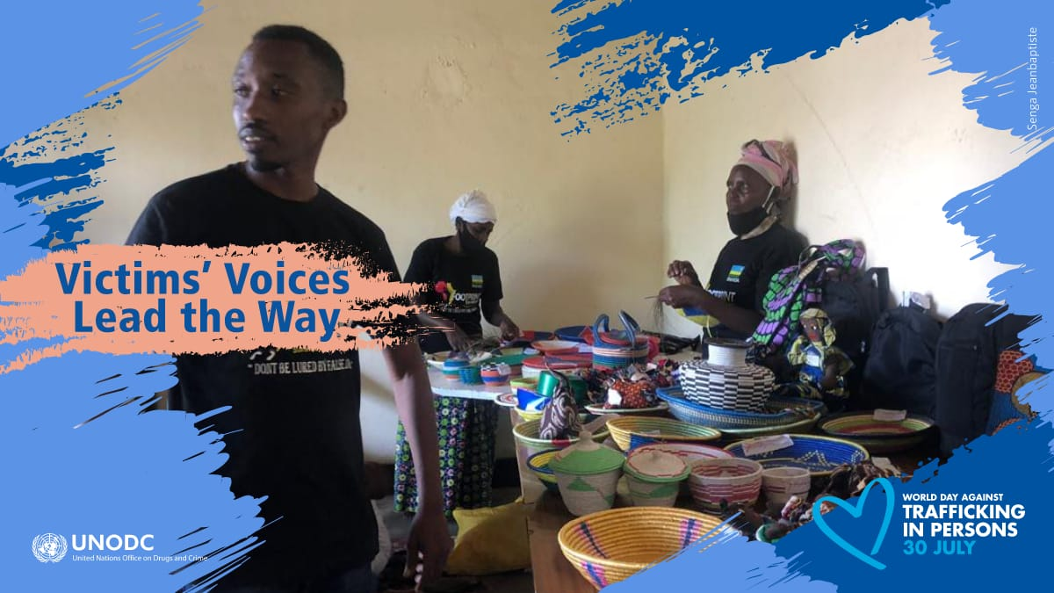

**OPERATIONAL HIGHLIGHTS**

**Nyadoi philister , The regional project coordinator Footprint to freedom, Ugandan chapter.** 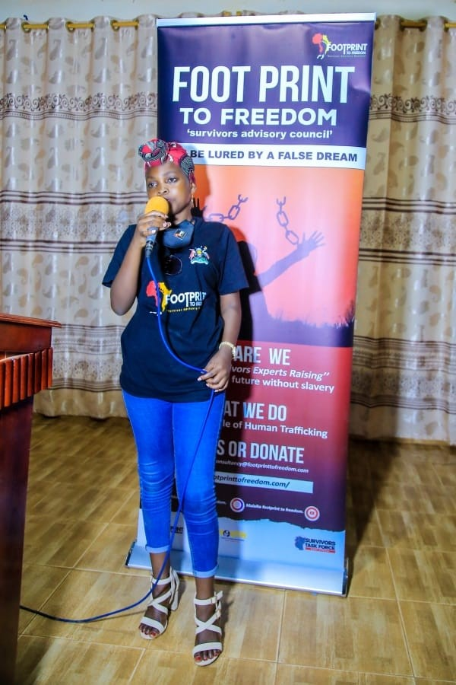

We held our most successful-to-date by doing outreach in schools in January 2020 thus sensitizing,pupils,teachers and the non-teaching staff in order to create awareness about child labour and human trafficking in society. We managed to extend /stretch our potential effort to outreach churches and communities in 2021.However we interacted with the youth, parents teenagers and the society at large ln accordance to educate them on how to avoid/prevent trafficking and be security keepers for each other, there was involvement of survivors/victims of human trafficking who acted as mouth piece to share their experiences through story telling hence creating awareness to the public.

Footprint to freedom has taken an obligation to partner with different Non-Government organizations that also has the same objective/goal of fighting human trafficking for insistence being in partnership with The Salvation Army (NGO) we rendered physical and financial support to launch the movie entitled “Dollar Salary” on 9th October 2021, that would go worldwide on media being viewed by a wide scope of people to create awareness on human trafficking that we couldn’t do verbally and spend faster than on media.

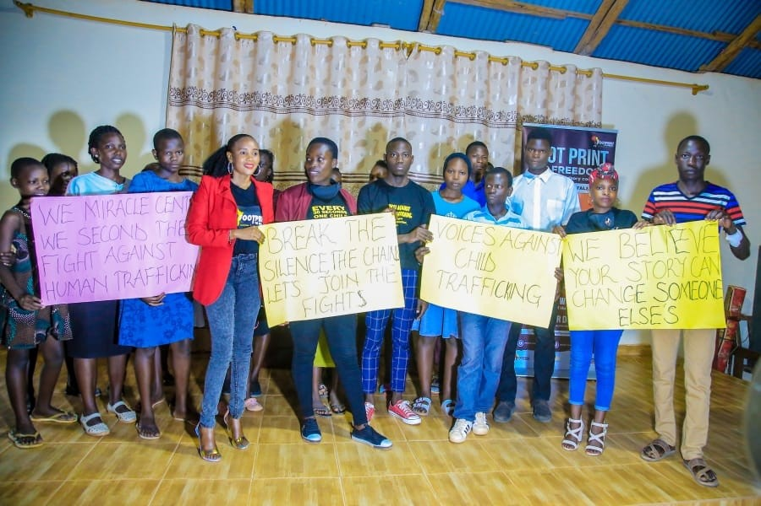**Amarango Pauline ,Survivor leader Footprint to Ugandan Freedom chapter.**

As a leader I created a network to inspire and connect survivors/victims of human trafficking. We do online guidance and counselling, outreach and training to reach out to people and those at risk of human trafficking, share our stories online because we believe someone’s story can change someone else’s story. Reaching out to people online would be the best option now due to the pandemic that has affected us in the way that we cannot meet people one on one because crowding would lead to faster spread of Covid 19.

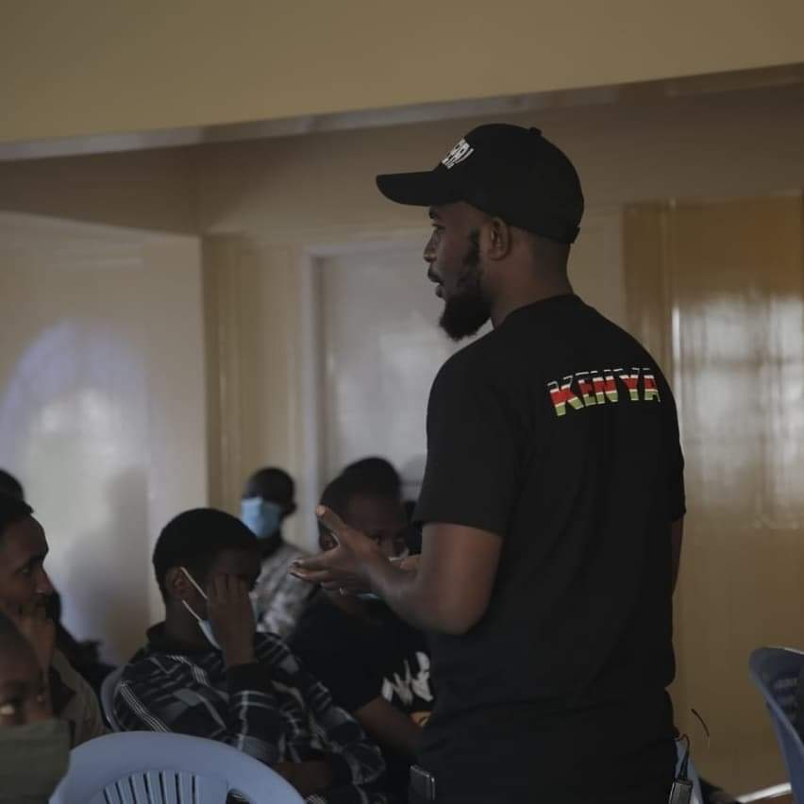

Footprint to freedom in Kenya reached out to and educated 500 children, both street children and school children about human trafficking, risks, and dangers of child labor, online sexual exploitation, and hosted child trafficking awareness-raising films

# FINANCIAL SUMMARY

**OUR FUNDING STREAM**

Optimizing the grant from Child10, Stichting HEEM, Evangelisatie valthe noorderdiep, valthernond, and Gifts from various churches and attendees in 2020 and 2021. we were able to push forward our mission of breaking the cycle of human trafficking by creating opportunities for survivors to thrive and empowering survivors to participate in our main activities; Prevention, Empowerment, and Education. Footprint to Freedom has been able to reach over 1000 schoolchildren, reached out to vulnerable communities in Uganda, Kenya, and Rwanda to sensitize them about human trafficking and empowered more than 300 survivors with entrepreneurial skills, and appeared on round table discussions across Europe and East Africa to advocate for better policies and services. ‘’We are on the mission to build slave-free communities’’





Join us and support our mission by donating/volunteering with us

You can make your donation here

IBAN: NL23RABO0318848147

BIC:RABONL2U

Rabobank

KvK: 76573001

contact address; Robinsonstraat 22, 8923 AS LEEUWARDEN

our website www.footprinttofreedom.org

Email us here!!

[Infor@footprinttofreedom.org](mailto:Infor@footprinttofreedom.org)

malaikaconsultancy@footprinttofreedom.org